IO Patterns PK
Li Wei<liwei@hp.com>

Target:
Question: Which Io Pattern (Server Mode or Thread Model) is the best in case of long lived connection?
Need proof! Mostly consider the throughput, latency.
Then how to do it?

Test Framework Introduction:
The socket test framework, no name now, or call it 3N.

History:
Based on Ravi’s New Diameter Codec Poc Project
Which includes：
PerfServer (Three Modes: STS, LFS, QAS)
PerfClient

The limitation is that server and client only support single connection mode, and the code is tightly coupled with diameter protocol.

References:
NETTY – http://jboss.org/netty
Mina - http://mina.apache.org/
Pattern-Oriented Software Architecture, Patterns for Concurrent and Networked Objects, Volume 2
by Douglas Schmidt, Michael Stal, Hans Rohnert and Frank Buschmann

Patterns Description:

Server Patterns:
- LFS (variant of Leader-Follower, using BlockingQueue to share threads between connections)
- QAS (Queue Async, using BlockingQueue to share read-threads between connections)
- NETTY (also is MINA’s mode)
- LF_IUM (only tested in one connection case)
- LF_E, LF_S, LF_E2, LF_S2 (variant of Leader-Follower, using Selector to share threads between connections, contributed by Wang, Xing-Lang)

About the Leader-Follower pattern, it is widely used in IUM, but it always start several threads for every connection, the threads can’t be shared by connections, which is a great waste, and can not full use the CPU resource in a lot of connections case. In the test, using LF-IUM to present it, using ReentrantLock to ensure the leader role atomic.
There are ways to share threads, in the LFS implementation, using BlockingQueue to match thread with connection. In the LF-E(2)/S(2), using Selector to match the thread with connection.

Note: Implementation of NETTY mode is just building server application on NETTY’s framework.

For detail descriptions, please refer to the pattern description file (IO Pattern PK.vsd). (Strongly recommend)
For LF_E, LF_S, LF_E2, LF_S2, in the Chapter: Conclusions/PK between Leader-Follower Variants, there is a brief introduction of them.
I believe the best description of Pattern is the code, if you want to understand them thoroughly, please go from method located in src/shark.server.PerfServer.start().

Client Pattern:
- ASYN (Send requests as fast as the client can, the only limitation is max pending request size, only support long-lived connection protocol and asynchronous message exchanging which means the next request needn’t to wait the response of previous request back)
Thread Model: for every connection, one sender thread and one receiver thread.
Procedure description: Build up all connections, after all warm up requests sent and corresponding responses back, then all senders of connections start to push server at the same time, that’s the start time of the test, until all receiver received all responses, that’s the end time of the test.
Throughput = total processed message number / (end test time – start test time).
Latency = response arrived time – request sent time.

Enhancement & Features:
- Flexible & Extensible Protocol Support
- Multiple Connections support in both server side and client side.
- Agent Mode support, which can test different server/client parameter combinations in batch.
- Probe load information of test server and test client
- Graphic Report

Performance Related Parameters description:

Server:
Name | Description | Used In
BLOCKING_MODE | No more comments, please refer to JDK Doc. | ALL
READ_BUFFER_SIZE | For every socket read operation, the max read bytes number, if less than that, read as much as it can. | QAS, LFS, LF_*
WRITE_BUFFER_SIZE | The max waiting to write to channel bytes number. | QAS (with WRITE_THREAD_POOL_SIZE > 0), LFS (with WRITE_THREAD_POOL_SIZE > 0)
THREAD_POOL_SIZE | The core process threads pool size. | ALL (For NETTY, it can be zero, means using IO thread for process)
READ_THREAD_POOL_SIZE | The read threads pool size. | QAS
WRITE_THREAD_POOL_SIZE | The write threads pool size. | QAS, LFS
MAX_READ_TIMES_PER_THREAD_CHANNEL | The max continuous read messages number of read thread for a particular channel | QAS
QUEUE_SIZE | The size of queue which store to be processed requests. | QAS, NETTY (with THREAD_POOL_SIZE > 0)
IO_THREAD_POOL_SIZE | The read/write threads pool. | NETTY
BATCH_PROCESS_NUMBER | Read several messages out per time, batch process them. This is a max value, no waiting; the actual process number can be less than it.  WARNNING: if enable batch process (this value bigger than 1), it will break the common rule: first come first served, In the same channel, the request came later may be processed earlier. It will cause some request will wait longer to be processed.  By default, in the test this feature is disabled. | ALL

Client:
Name | Description
WARM_UP_NUM_MESSAGES | Before the real test, how many warm up messages should be sent?
NUM_MESSAGES | The total request count for a single connection.
READ_BUFFER_SIZE | As in Server Mode.
MAX_PENDING_REQUESTS_PER_CONNECTION | For every connection, the max allowed requests which haven’t been answered.
CONNECTION_NUM | The total connections build from client to serer.
TEST_TIMES | Test several times; pick the best of throughput as the final result.

Socket:
Name | Description
SOCKET_RECV_BUFFER_SIZE | No more comments.
SOCKET_SEND_BUFFER_SIZE | No more comments.
TCP_NODELAY | No more comments.

Agent Mode:
Agent is the coordinator between server and client for performance test.
It does the following things:

Read parameters file

For every Test Round (a combination of server parameters and client parameters)
Do {
Remote set server parameters to server
Remote set client parameters to client
Remote start server with specified mode for processing messages
Remote start client, start the test.
Remote gather server, client load info until the test is over.
Remote get report from client
}

After all test rounds are done, write the report file.

My Test: VL

Protocol:
Anonymous - A simple binary protocol on TCP

0 1 2 3
0 1 2 3 4 5 6 7 8 9 0 1 2 3 4 5 6 7 8 9 0 1 2 3 4 5 6 7 8 9 0 1 2
+-+-+-+-+-+-+-+-+-+-+-+-+-+-+-+-+-+-+-+-+-+-+-+-+-+-+-+-+-+-+-+-+
| Message Length |
+-+-+-+-+-+-+-+-+-+-+-+-+-+-+-+-+-+-+-+-+-+-+-+-+-+-+-+-+-+-+-+-+
| Request-Response ID |
+-+-+-+-+-+-+-+-+-+-+-+-+-+-+-+-+-+-+-+-+-+-+-+-+-+-+-+-+-+-+-+-+
| Body...
+-+-+-+-+-+-+-+-+-+-+-+-+-+-+-+-

Server Process Logic:
Simple Echo Server (Response is equal to Request);
Include some dummy logic which consumes CPU.

Performance Related Parameters description:

Protocol:
Name | Description
REQUEST_SIZE | The message size of request and response, the unit is byte.
SERVER_LOGIC_COMPLEXITY | Code is like  int num =ServerConstants.SERVER_LOGIC_COMPLEXITY;  List<Integer> ints = new ArrayList<Integer>();  for (int i = 0; i < num; i++) {  ints.add(i);  }  Collections.binarySearch(ints, random.nextInt(num));  Collections.sort(ints, desc);  if (ServerConstants.SERVER_LOGIC_SLEEP_TIME > 0) {  Thread.sleep(ServerConstants.SERVER_LOGIC_SLEEP_TIME);  }  Collections.sort(ints, asc);  //NOTE, to simulate the real environment, the number of created objects will be proportional with the complexity of the logic.
SERVER_LOGIC_SLEEP_TIME | Not Used in the test, when enable it, throughput dropped badly; seeking for better way to simulate no CPU bound operations.

Environment:

Test machines:
IP | CPU | JDK | OS
16.91.113.17 | 8 Core - Intel(R) Xeon(R) CPU X5460 @ 3.16GHz | Java HotSpot(TM) 64-Bit Server VM (build 14.3-b01, mixed mode) | x86_64 GNU/Linux 2.6.18-53.el5
16.91.113.21 | 4 Core - Intel(R) Xeon(R) CPU 5160 @ 3.00GHz | Java HotSpot(TM) 64-Bit Server VM (build 11.0-b16, mixed mode) | x86_64 GNU/Linux 2.6.18-53.el5

Server JVM parameters:
-server -Xmx512m -Xms512m -XX:MaxNewSize=64m -XX:NewSize=64m -XX:+UseConcMarkSweepGC

Test Report:
For detail report, please refer to the report files.
NOTE: There are so many parameters that affect the performance outcome; the test tried to run compared cases in a fair environment as much as possible. And there are too many combinations of server parameters and client parameters, it is impossible to cover all situations, the test only chooses the representative cases after huge amount of test.

Graph Description：
There is one X axis, stands for categories; one category stands for one kind of client parameters.
There are five Y axes, stands for throughput, average latency, most below average (the most definition is configured in configuration file, the default value is 0.999, means 99.9% latency below the calculated value), server CPU usage and client CPU usage (the percent is measured on CPU Core usage level, means for machine with 8 CPU cores, the max usage percent is 800%).
The column in the same color means they are measured under the same server parameters, same color columns in the same category means they are different indexes of the same round of test.

Conclusions:

Special case: one connection
NETTY (1 IO, 7 Process) is the best, there is only one blocking queue existing.
NETTY(8 IO), is bad, because when there is only one connection, only one thread is used, so the server CPU usage is no more than 100%.
LFS and QAS, when enable async write (use write thread for all write operation) is better than sync write, because the socket write is a synchronized operation, batch write is better, it will cut down the contention rate, but they are all worse than NETTY (1 IO, 7 Process), because they have more blocking queues than NETTY.
IUM-LF, through profile, during the test there are too many lock contentions on socket write.
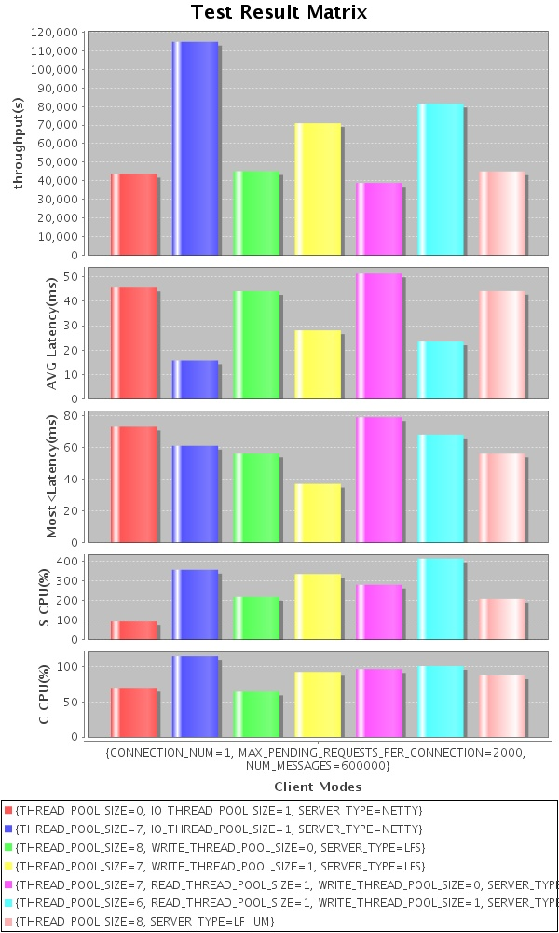
One connection case (NETTY, LFS, QAS, LF_IUM)
Note: if you want to see the accurate figure of every index, please go to the report folder, open the related html file.

Relation with connection numbers
When connections number < CPU Core Number
The best is NETTY (1 IO, 7 Process)
When connections number >= CPU Core Number
The best is NETTY (8 IO)

For NETTY (8 IO), when there is less connection number than CPU core number, it can not full use the CPU, so the throughput is bad, when there are more connections, it can achieve the highest throughput and the lowest average latency.
For LFS, QAS, when there are fewer connections, using async write improved a lot, but as the connection number increasing, rate of write lock contention is decreased, so the performance difference is diminished, you can compare the red with the blue.

Note: on different message size and different server logic, the result may be different, this is just a reference.
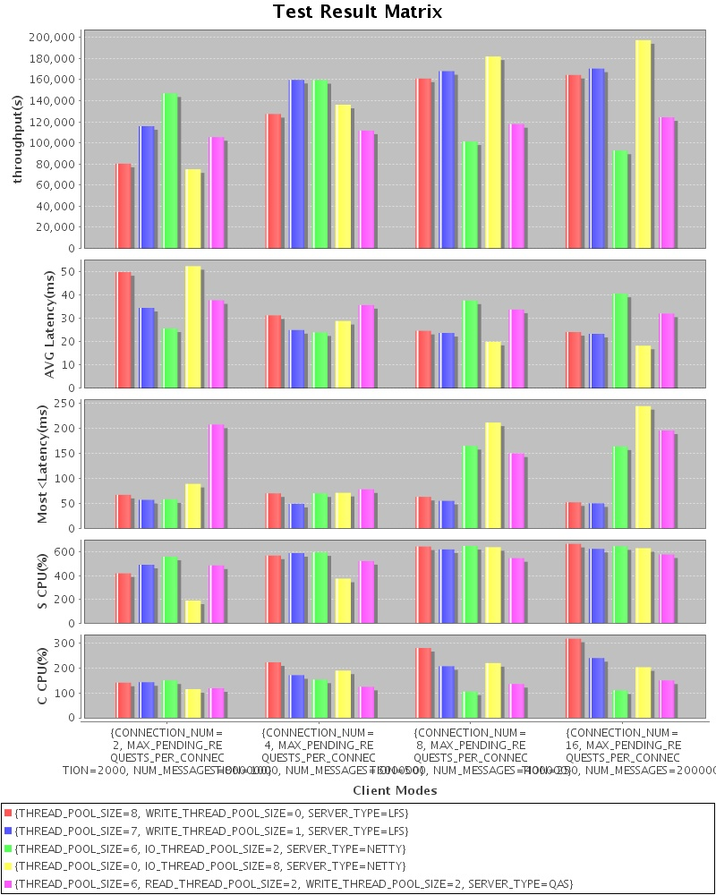
Relation with connection numbers (2, 4, 8, 16)

Relation with message size
When the message size is large enough, there is no big difference between the IO patterns. Through the following graph, you can see the trend.

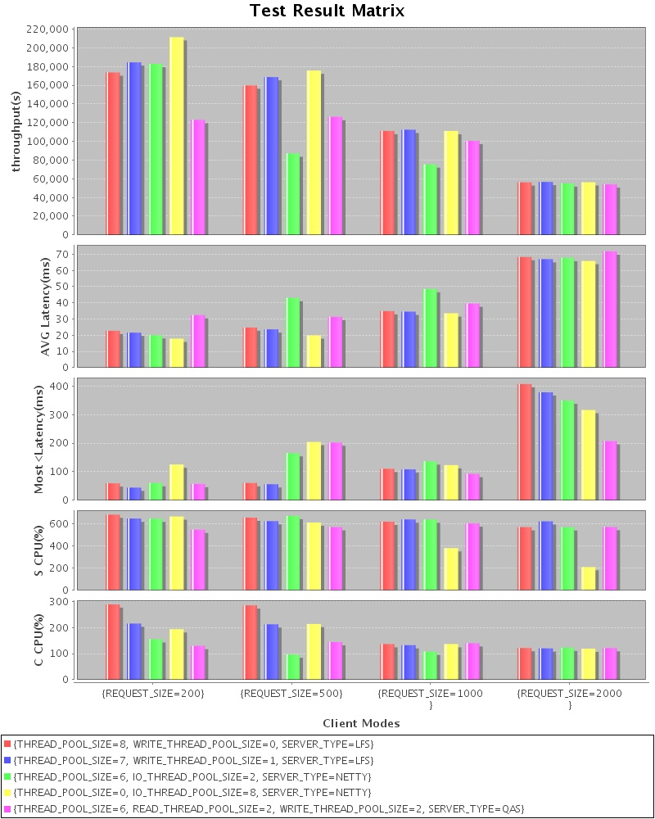
Relation with message size (200, 500, 1000, 2000)

Relation with server logic
The throughput dropped as server logic becoming more complex, and pattern’s performance differences become diminished.

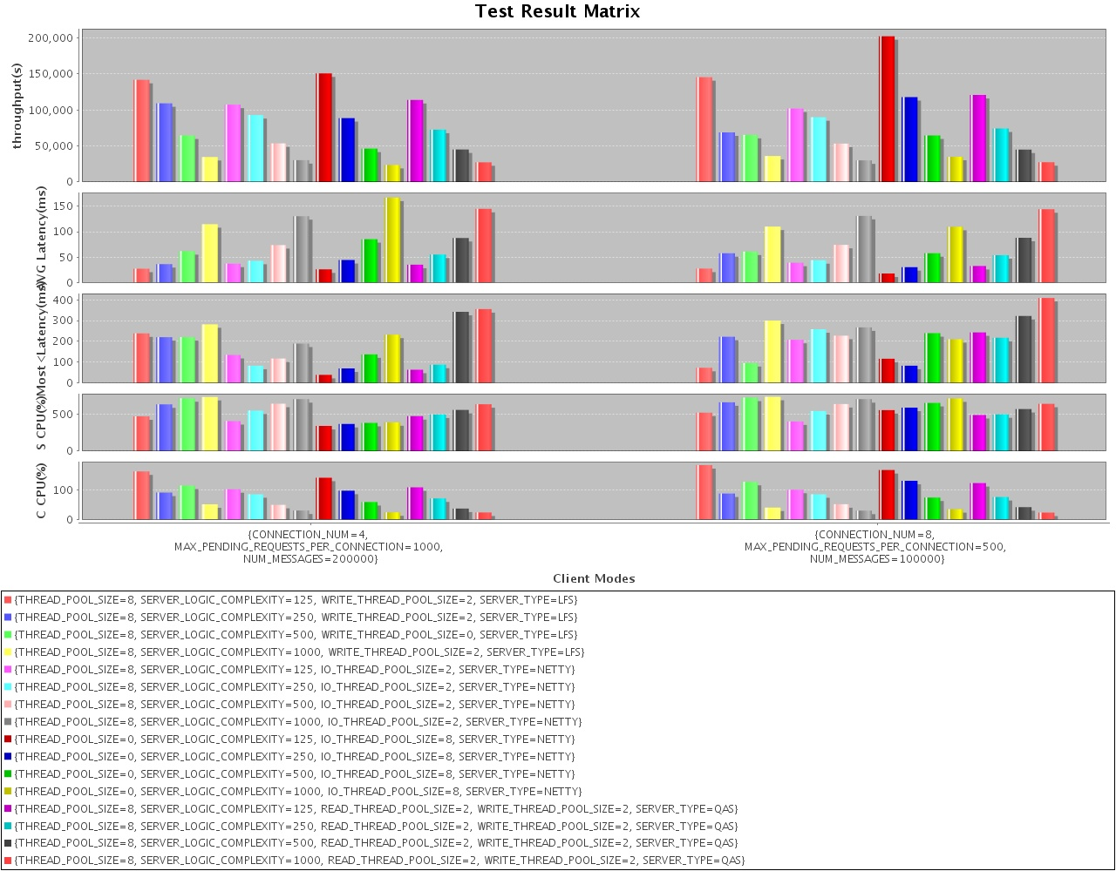
Relation with server logic (125, 250, 500, 1000) on connections number (4, 8)

PK between Leader-Follower variants
For Leader-Follower variants that support thread sharing between connections.

Here is a brief introduction of LF_E(2)/S(2) patterns: it is using NIO selector to associate thread with connections, one selector listen for all connections, firstly one LF thread do the select and cache the readable channel, the other LF threads get the channel from the cache, read message (LF_E/S will only read one message from channel, but LF_E2/S2 will read several messages out), do the process, once the cache is empty, redo the select operation by the present LF thread.

The result of PK:
When disable batch process:
LF_S and LF_E is not good compared to LFS, because there is no buffer for bytes read from socket (Why no buffer? if you read all messages into the read buffer from the socket buffer, but only processed one of it, it is possible that, in the next time, the channel will not be selected out by the selector, then your previous read out messages will not be able to executed), and may be the select operation of selector is not efficient enough either, this need to be verified.

When enable batch process:
There is no big difference between LFS, LF_E2/S2.
The performance improved a lot in case of LF_E2/S2 compared to LF_E/S, it will read several complete messages out from socket according to the receive buffer size, and then do the batch process for received messages.
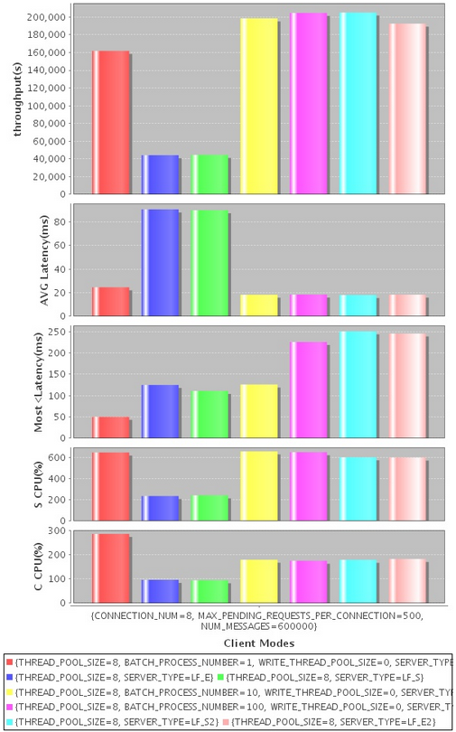
PK between (LFS, LF_E, LF_S, LFS [batch enabled], LF_E2, LF_S2) on connections number (8)

Relation with batch process
For the meaning of batch process, please refer to Server Parameter: BATCH_PROCESS_NUMBER.
Batch process improved the LFS, QAS a lot, but didn’t help NETTY too much, because, LFS, QAS are using BlockingQueue which contains some lock contention. Using batch process, the rate of contention decreased.
But the most below latency is worse when enabling batch process, because some requests are delayed to be processed.
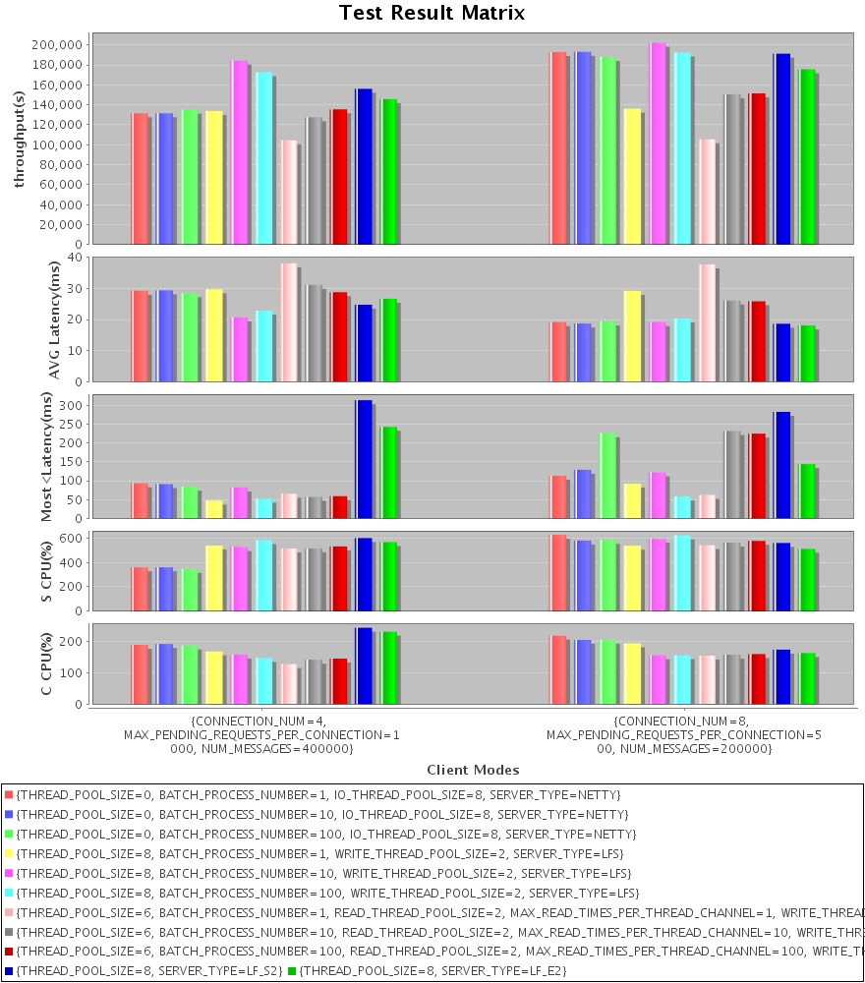
Relation with Batch Process (1, 10, 100) on connections number (4, 8)

Total Conclusion
In different case or situation, different IO pattern win, overall, the NETTY is flexible enough to handle all cases just by configurations.
But it has its limitations:
- When the possible connections number is varied, for example sometimes it is below CPU cores, sometimes it is up the CPU cores, how to configure thread model in that case is a problem.
- It is not fair in some situation; because the relation between IO thread and connection is fixed, sometimes, one connection is too busy, but another connection is kind of idle, the IO threads will not be full used.

The performance of LFS is kind of good and stable during all kinds of test case.

QAS is worse than LFS in general, additional Message BlockingQueue is the cause. But if in case of complex server logic (including no CPU bound operations), the result is hard to say. Need validation.

Batch Process, I think it is quite debatable, the question is should we comply with the FCFS (First-come, first-served) rule strictly?

To-Do In The Future
The compared thread models are all fixed, we can even consider have a dynamic thread model, which can adapt to the real traffic environment.

Run the test by yourself:

Steps
Start the server ( ./server.sh or server.bat)
Start the client (.client.sh or client.bat)
Edit the parameters property file contains parameters combinations of server’s and client’s.
Start the agent with your parameters property file to go. (./agent.sh parameters.xml or agent.bat parameters.xml)
Watch the process information printed by the agent until test done.
View the result it generated.

Choose the best pattern for Your Application
It is easy to simulate your application, just like the sample test.
Implement the interfaces: ClientSPI, SererSPI, ProtocolSPI

Want To Challenge?
If you have ideas of other IO pattern, implement and test it on the test framework, PK with the existing patterns. I believe there will be better patterns!

